- Find Duplicate in Array.
Given a read only array of n integers between 1 and n, find one number that repeats.
Input Format:
First Line - Number of elements
n Lines - n Elements
Output Format:
Element x - That is repeated

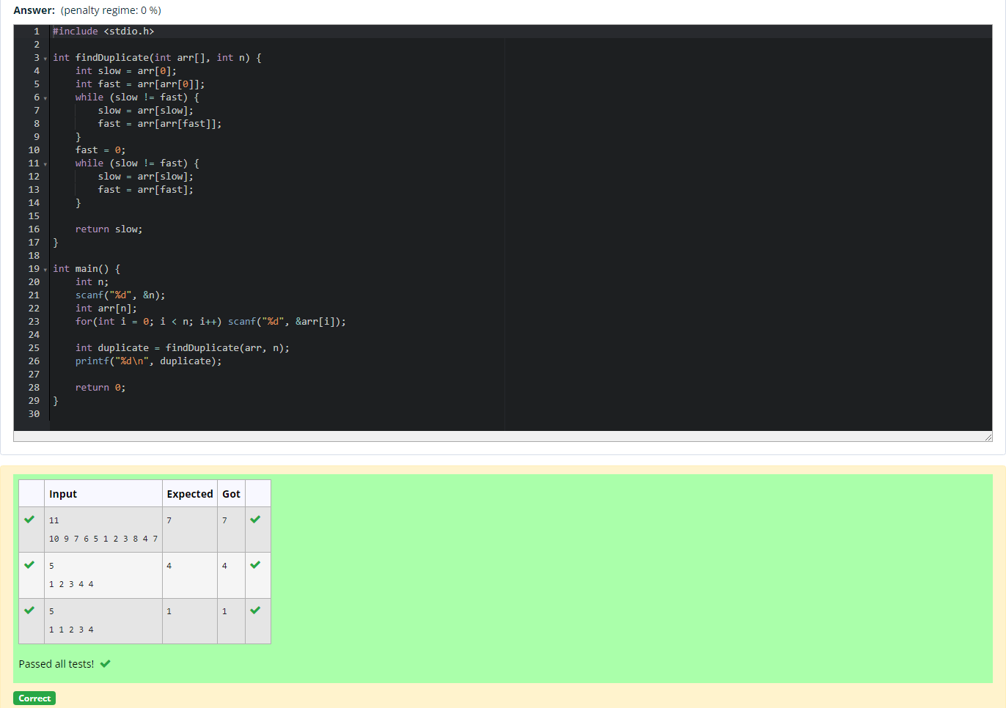

- Find Duplicate in Array.
Given a read only array of n integers between 1 and n, find one number that repeats.
Input Format:
First Line - Number of elements
n Lines - n Elements
Output Format:
Element x - That is repeated

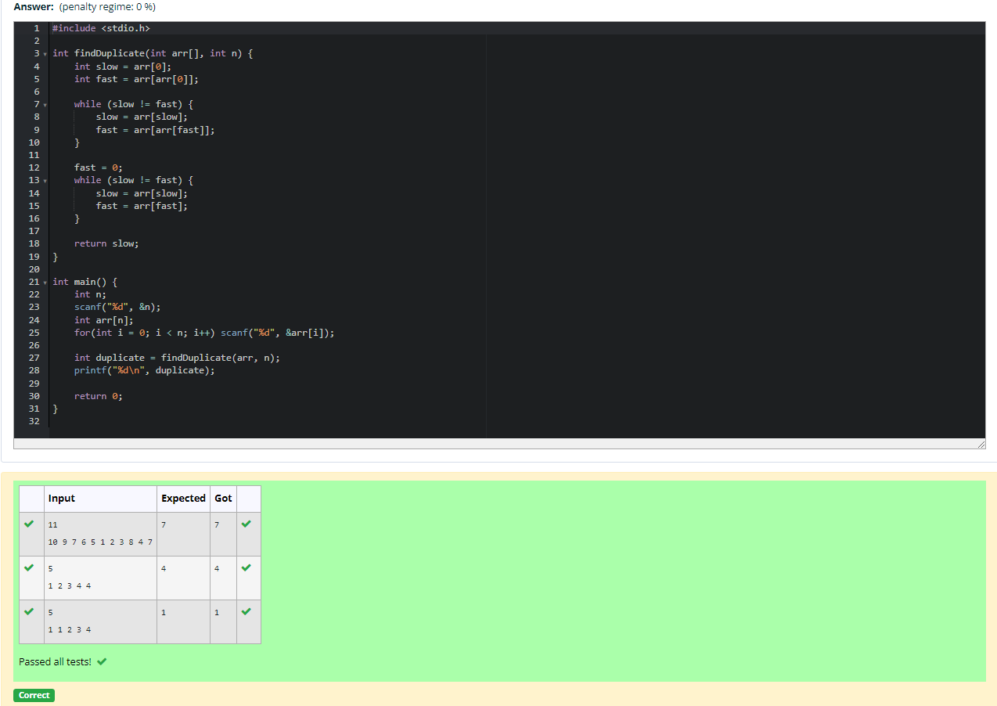

- Find the intersection of two sorted arrays.
OR in other words,
Given 2 sorted arrays, find all the elements which occur in both the arrays.
Input Format
· The first line contains T, the number of test cases. Following T lines contain:
1. Line 1 contains N1, followed by N1 integers of the first array
2. Line 2 contains N2, followed by N2 integers of the second array
Output Format
The intersection of the arrays in a single line

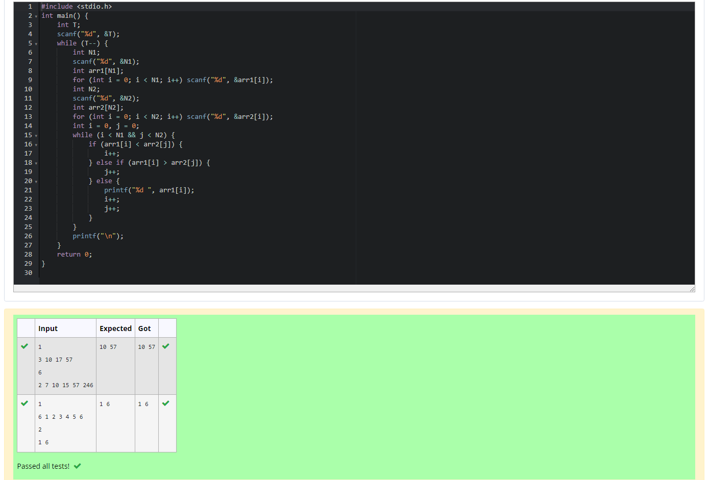

- Find the intersection of two sorted arrays.
OR in other words,
Given 2 sorted arrays, find all the elements which occur in both the arrays.
Input Format
· The first line contains T, the number of test cases. Following T lines contain:
1. Line 1 contains N1, followed by N1 integers of the first array
2. Line 2 contains N2, followed by N2 integers of the second array
Output Format
The intersection of the arrays in a single line

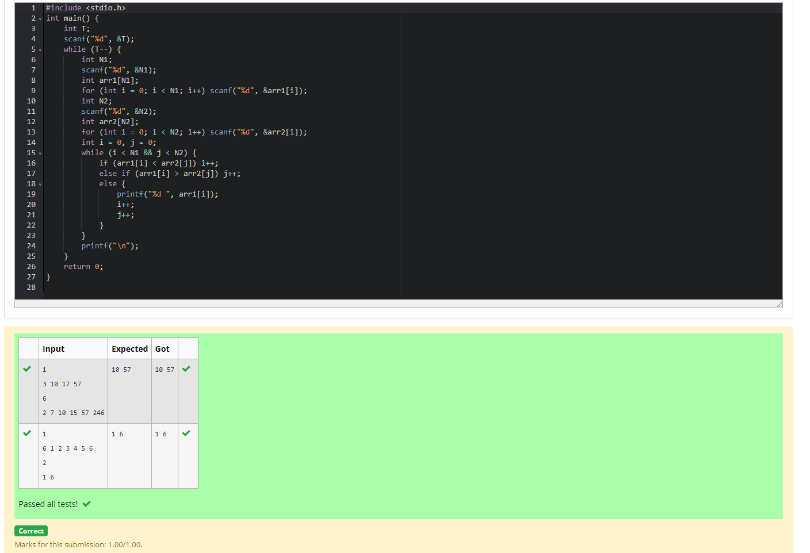

- Given an array A of sorted integers and another non negative integer k, find if there exists 2 indices i and j such that A[j] - A[i] = k, i != j.
Input Format:
First Line n - Number of elements in an array
Next n Lines - N elements in the array
k - Non - Negative Integer
Output Format:
1 - If pair exists
0 - If no pair exists
Explanation for the given Sample Testcase:
YES as 5 - 1 = 4
So Return 1.

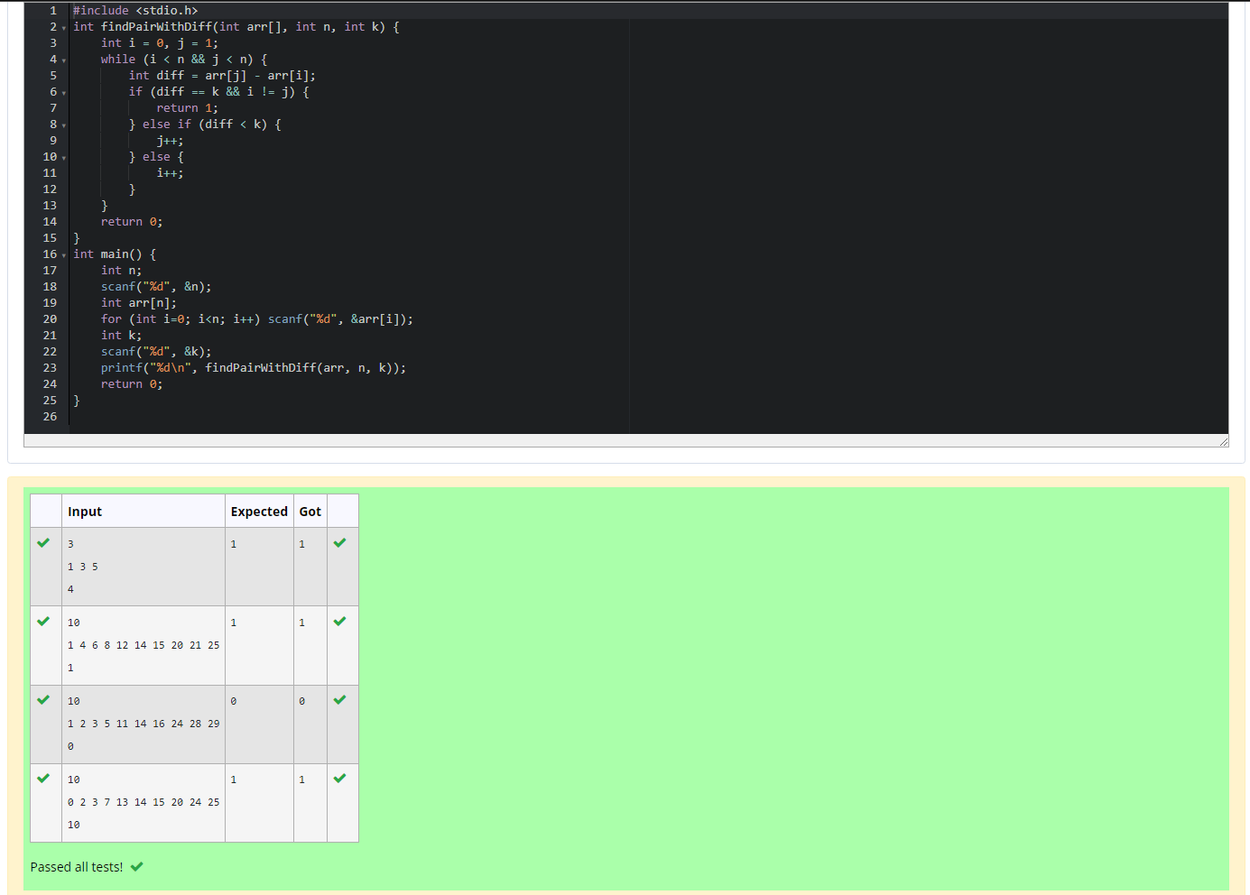

- Given an array A of sorted integers and another non negative integer k, find if there exists 2 indices i and j such that A[j] - A[i] = k, i != j.
Input Format:
First Line n - Number of elements in an array
Next n Lines - N elements in the array
k - Non - Negative Integer
Output Format:
1 - If pair exists
0 - If no pair exists
Explanation for the given Sample Testcase:
YES as 5 - 1 = 4
So Return 1

